press release 2.
AURA – THE LUXURY TRAVEL EVENT LIGHTS UP FLORENCE
AND LUXURY TOURISM LOOKS TO THE ITALY BRAND
From 27 to 29 October at the Fortezza da Basso, Italian Exhibition Group’s new event for high-end tourism. Despite a complex international scenario, the luxury segment is proving to be highly resilient: according to TTG Monitor, 46% of high-end travellers say they will be sticking to the same budget as last year for their upcoming holidays, whilst 30% foresee an increase in expenditure. The AURA programme, featuring B2B workshops, networking opportunities and chances to explore the local area, will focus on the encounter between international buyers and hotel and high-end hospitality service operators
Florence, 25 June 2026 – Luxury is no longer confined to the most exclusive suites or opulent surroundings. Nowadays, it is measured by the chance to enjoy extraordinary experiences: a museum visit outside normal opening hours, a meeting with an artist, a bespoke Michelin-starred dinner, or an itinerary that becomes a personal narrative. AURA – The Luxury Travel Event comes within this new realm of desire, an international event, organised by Italian Exhibition Group, specifically for high-end tourism, scheduled to take place from 27 to 29 October 2026 at the Fortezza da Basso in Florence.
For three days, Florence will become the meeting point for the very best of Italy’s offer and the international experts who design tailor-made trips for high-spending clients: luxury travel advisers, ultra-luxury travel designers, specialist operators and buyers selected from the main international markets, arriving from strategic regions such as North America, South America, Asia, Europe and the United Kingdom. The focus will be on dialogue with a selection of five-star hotels, luxury hotel brands, historic residences, resorts, villas, castles, high-end incoming tour operators and services linked to transport, hospitality and experiences.
AURA – The Luxury Travel Event will be a business platform as well as a dynamic observatory on the evolving language of luxury travel. The programme will feature over 10 hours of B2B workshops, networking sessions, talks on high-end tourism trends, and opportunities to explore the local area, all with the aim of connecting international demand with high-end hotels and exclusive services.
Experiences, part of the programme and a vivid account of new luxury travel, come within a business, relationship and market-oriented project. Tourism professionals will have the chance to explore Italy’s know-how, transforming places, gestures and skills into high-value travel content. The programme will include visits to Palazzo Pucci, the Ferragamo and Gucci Museums, as well as courses and workshops with organisations such as My Mancini, Stefano Bemer, Il Bisonte and La Ménagère, and a workshop on upcycling and textile regeneration. From the history of Florentine fashion houses to bespoke shoemaking, hand-crafted leather goods and the culture of hospitality.
This demand for quality, content and personalisation is driving a market that is currently undergoing a major repositioning. Luxury tourism is now one of the most dynamic segments in the Italian tourism sector. According to the Deloitte report, it accounts for over 9 billion euros in direct spending in Italian five-star hotels, equivalent to approximately 16.8% of the national hotel sector’s total turnover.
“In a complex international landscape, the luxury segment continues to show considerably strong resilience,” says Gloria Armiri, Group Exhibition Manager of IEG’s Tourism & Hospitality Division. “Luxury is a key driver of growth for Italy. The buyers surveyed for our TTG Monitor confirm that 46% of customers are willing to spend as much as last year and 30% foresee increasing their budget. But the most interesting finding concerns the shift in perspective: high-spending tourists choose Italy for the quality of its services and experiences, prioritising authentic sensations over budget. According to 72% of those surveyed, luxury no longer equates to ostentation, but to exclusive, personalised experiences with high emotional value. Bookings for the coming months do not appear to be affected by international tensions, and long-haul markets continue to put our country at the centre of their wish-list. The ‘Italy’ brand is solid and the increase in international investment in high-end assets is the tangible proof.”
Aura – The Luxury Travel Event originates from Italian Exhibition Group’s expertise in tourism and its presence in professional markets. AURA is, in fact, an evolution of the Luxury Event by TTG format, which, at its most recent edition, facilitated over 1,600 business meetings between international operators. This process is now taking a further step forward with an event entirely dedicated to the luxury segment that aims to provide the Italian tourism sector with a specialised, international B2B platform built around the quality of relationships.
Furthermore, the choice of Florence is no coincidence. The city offers AURA a setting in which art, fashion, craftsmanship, manufacturing and hospitality have gone hand in hand for centuries, making the transition from luxury as a status symbol to luxury as an experience a natural one. AURA was launched with the support and collaboration of the Region of Tuscany, alongside Toscana Promozione Turistica, the Destination Florence Foundation and Firenze Fiera.
Institutional partners: Region of Tuscany; Main Partner: Toscana Promozione Turistica; Host and Destination Partner: Destination Florence Foundation; Venue Partner: Firenze Fiera; Media Partner: TTG Luxury.

MEDIA AGENCY TTG TRAVEL EXPERIENCE
Martina Vacca: martina@mindthepop.it, mob. +39 339 748 5994; Fabrizio Raimondi: fabrizio@mindthepop.it, mob. +39 335 389 848; Benedetto Colli: benedetto@mindthepop.it, mob. 380 371 2272.

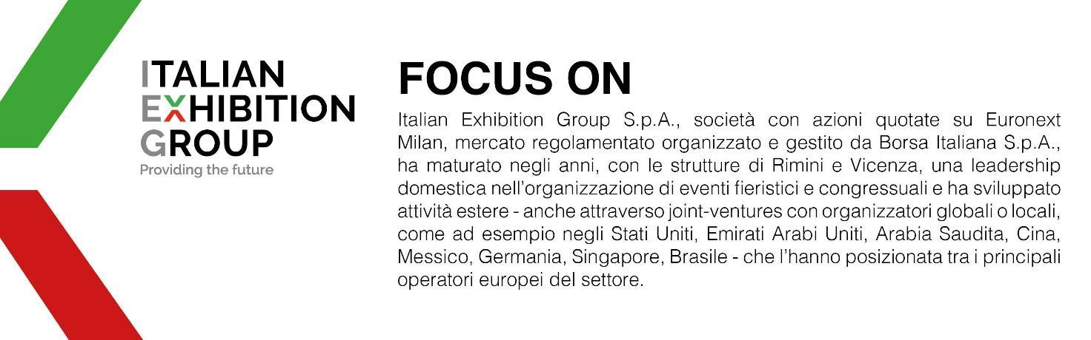

This press release contains forecast elements and estimates that reflect the management´s current opinions (´forward-looking statements´), particularly regarding future management performance, realization of investments, cash flow trends and the evolution of the financial structure. For their very nature, forward-looking statements have a component of risk and uncertainty, as they depend on the occurrence of future events. The effective results may differ (even significantly) from those announced, due to numerous factors, including, only by way of example: food service market and tourist flow trends in Italy, gold and jewellery market trends, green economy market trends; the evolution of raw material prices; general macroeconomic conditions; geopolitical factors and evolutions in the legislative framework. Moreover, the information contained in this release, does not claim to be complete, and has not been verified by independent third parties. Forecasts, estimates and objectives contained herein are based on the information available to the Company as at the date of this release.

