press release
AURA, THE NEW INTERNATIONAL EVENT THAT IGNITES THE LUXURY TRAVEL BUSINESS
Today’s press conference launches Italian Exhibition Group’s luxury tourism event.
The Deloitte report: over 100 new luxury hotels and about 9,600 rooms will be available in Italy in the coming years with a growth that will support undertourism.
Florence, 30th March 2026 – AURA – The Luxury Travel Event, the international event entirely dedicated to luxury tourism, conceived and organised by Italian Exhibition Group (IEG), was presented in Florence today at Palazzo Guadagni Strozzi Sacrati during an official press conference.
The AURA event was created with the support and collaboration of the Region of Tuscany, alongside Toscana Promozione Turistica, the Destination Florence Foundation and Firenze Fiera, confirming a shared vision for positioning Italy within the high-end segment. A project that marks an important milestone for the national tourism sector. This international B2B initiative specifically for the luxury segment was, in fact, devised by an Italian player with an in-depth knowledge of the market, with the aim of establishing a direct link between the excellence of Italy’s offerings and leading global buyers.
The event will take place from 27th to 29th October 2026 at the Fortezza da Basso in Florence, which, for three days, will become the international reference point for high-end tourism.
THE ECONOMIC OUTLOOK AND THE DELOITTE REPORT
Luxury tourism is now one of the global market’s most dynamic segments with direct spending on five-star hotels in Italy exceeding 9 billion euros, accounting for approximately 16.8% of the national hotel sector’s total turnover.
Among the most significant findings of the Deloitte report presented in Florence is a sharp acceleration in investment: over the three-year period 2026–2029, more than 100 new luxury-branded hotels and around 9,600 rooms are expected to become available in Italy. However, the most significant fact concerns the structural shift in the market: luxury is no longer confined exclusively to major cities, but is increasingly expanding towards emerging destinations and areas with strong appeal. As a result, numerous locations are becoming more popular: from coastal destinations to lakes, mountain areas and inland villages.
Investment in high-end tourism is increasingly driven by strategic considerations: priority is given to destinations that combine scenic beauty, cultural identity and good infrastructure. Factors that make Italy particularly attractive for new luxury projects include its cultural and scenic heritage, its food and wine offerings, and the chance to convert historic buildings into high-end hotels. It is no coincidence that almost 60% of investors cite Italy as the most promising European market for the development of new luxury hotels over the next three years.
AURA AND IEG’S VISION: THE ITALIAN EXPERIENCE AT THE HEART OF GLOBAL LUXURY TOURISM
“AURA stems from a deep understanding of the market and extensive experience in building international platforms,” said Corrado Peraboni, Chief Executive Officer of Italian Exhibition Group. “A know-how that also derives from our track record in tourism with TTG Travel Experience, the leading event that has been anticipating and interpreting developments in the sector for over 60 years. With this project, we aim to provide the Italian tourism sector with a practical tool to compete at the highest level of global tourism by creating valuable connections between operators and buyers.”
“Rather than just an event, AURA is a business platform that focuses on quality and experience,” added Gloria Armiri, Group Exhibition Manager of IEG’s Tourism & Hospitality Division. “The figures presented today tell us that the luxury sector is changing. It is opening up to new destinations, new forms of travel and a demand that is increasingly oriented towards authenticity. Italy holds all the cards for leading this evolution.”
By showcasing both iconic and emerging destinations in an increasingly competitive international landscape, AURA aims to be a strategic initiative designed to strengthen Italy’s position in the high-end tourism sector. The event will bring Italian excellence — five-star hotels, historic residences, bespoke experiences and exclusive services — into direct contact with international operators that have a tangible impact on high-end tourism flows. Three days of B2B meetings and international networking, as well as an immersive experience: alongside meetings, the format will include opportunities to discover Italy, its culture and Italian savoir faire, elements that are becoming more and more central to the new concept of luxury. AURA was created to fill a gap in the system by offering the Italian market a robust, internationally-scaled platform, conceived and developed by Italian professionals and built on a direct understanding of the sector and its dynamics, capable of driving growth across the entire supply chain.
AURA is, in fact, an evolution of the Luxury Event by TTG format, which, at its most recent edition, amassed over 1,600 business meetings between international industry professionals, confirming the growing demand for high-end, customised tourism experiences. It is now taking a further step forward with a project entirely dedicated to the luxury segment.
Institutional partners: Region of Tuscany; Main Partner: Toscana Promozione; Host and Destination Partner: Destination Florence Foundation; Venue Partner: Firenze Fiera; Media Partner: TTG Luxury.

MEDIA AGENCY TTG TRAVEL EXPERIENCE
Martina Vacca: martina@mindthepop.it, mob. +39 339 748 5994; Fabrizio Raimondi: fabrizio@mindthepop.it, mob. +39 335 389 848; Benedetto Colli: benedetto@mindthepop.it, mob. 380 371 2272; Stefano Chiossi: stefano@mindthepop.it, mob. + 39 388 739 4358.

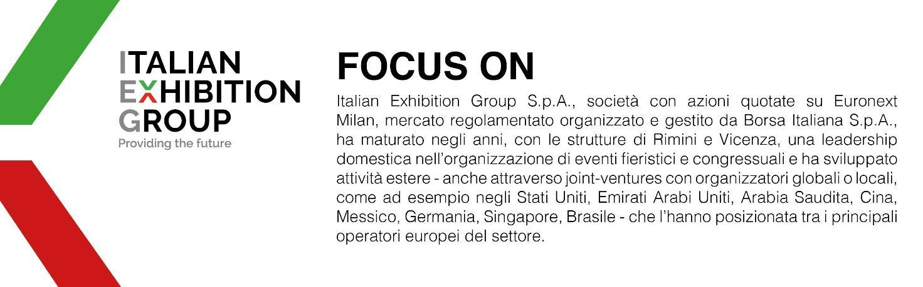

This press release contains forecast elements and estimates that reflect the management´s current opinions (´forward-looking statements´), particularly regarding future management performance, realization of investments, cash flow trends and the evolution of the financial structure. For their very nature, forward-looking statements have a component of risk and uncertainty, as they depend on the occurrence of future events. The effective results may differ (even significantly) from those announced, due to numerous factors, including, only by way of example: food service market and tourist flow trends in Italy, gold and jewellery market trends, green economy market trends; the evolution of raw material prices; general macroeconomic conditions; geopolitical factors and evolutions in the legislative framework. Moreover, the information contained in this release, does not claim to be complete, and has not been verified by independent third parties. Forecasts, estimates and objectives contained herein are based on the information available to the Company as at the date of this release.

